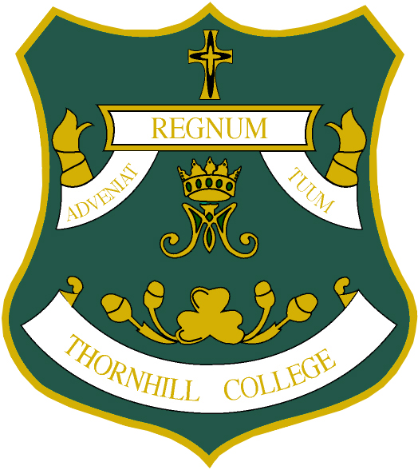

THORNHILL COLLEGE

Admission to Year 13

Academic Year 2019 - 2020

Personal Details

Name

Address

Postcode

Subject Choices

Please state the 3 or 4 subjects you may wish to study at Thornhill College.

Subjects
1.

2.

3.

4.

Please return this form to Mr D McCay, Head of Senior School, at Thornhill College 142 Culmore Road, Derry, BT48 8JF or email to dmccay658@c2kni.net

