Summer Reading Challenge
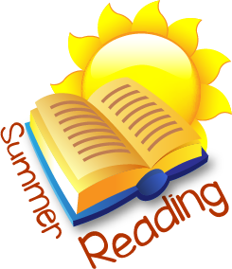

On your return to school in September your English teacher will expect you to have completed two tasks based on your summer reading. You should choose two of the books you have read over the summer and complete one task for each chosen book. Attached is a suggested reading list but you may wish to choose your own books.
Task 1 – Book 1 - Formal Book Report
You should write a report on your book. It should be 250 words minimum. Remember to paragraph your work and check spelling, punctuation and grammar before handing up the final draft to your teacher in September. Your book review should include the following elements:
- Brief synopsis
- Your favourite part of the book and why
- Your favourite character(s)
- Your least favourite character(s)
- What you thought of the book
- What you would like to change
Task 2 –Book 2 - Creative response
For this task you should choose one of the activities from the list below. You will be expected to give a formal presentation to your class on this task. This will take place in the first week in September. You could:
- Create a powerpoint presentation
- Create an advertisement for the book – poster, radio, etc
- Design a website for the book (think of Pottermore) NB You do not have to actually create it – you can have sketches and a short presentation explaining what the website will be like
- Make a short video clip based on the book
- Write another chapter which occurs before the book opens, or after it ends
- Write an alternative ending – closing chapter for the book
- Write a speech about the book, convincing your audience it is either the best, or worst book ever written and why it should, or should not, be included on the school curriculum
- Write a news article about an important event from the book
- Write a letter to the author explaining what you thought of the book, what you would change and any queries you might have
- Write a report for a magazine, based on an imaginary interview with a character or the author.

