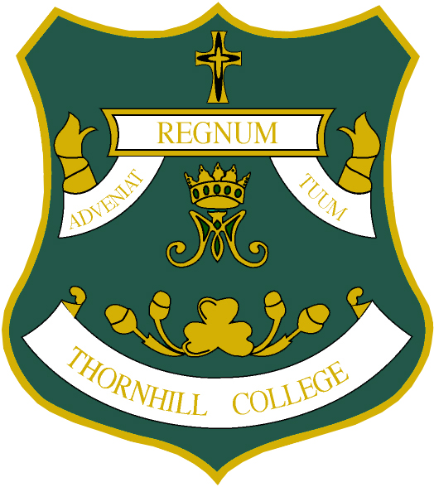

THORNHILL COLLEGE

Admission to Year 13

Please fill in your details below and an application pack will be posted to your home address in June.

Personal Details

Name

Address

Postcode

Subject Choices

Please state the 3 subjects you may wish to study at Thornhill College.

Subjects
1.

2.

3.

Please return this form to Mr D McCay, Head of Senior School, at
Thornhill College 142 Culmore Road, Derry, BT48 8JF
or email to dmccay658@c2kni.net

